AVONBITS CRS CALCULATOR.

1. Configurations instructions.

CRS-Comprehensive Ranking System Calculator is created for Android phones by Avon Bits Inc Sellers. CRS calculator is really helpful for mainly international students and workers. CRS Calculator point-based system users can access this application to assess and score their profile for the express entry pool. This application is totally free for android users. This application different from other CRS calculator in the android market. It has some upgraded features such as it gives a free suggestion to user that how and what they can do to get eligible for express entry pool. This application also updates the users about the changes of any rule and regulations regarding scheme for calculating the points.



2. Installation instructions.

a. Open the google play store

b. Then search for the app name AVONBITS CRS calc in a search bar

C. Then click on the download option

d. Then it will start downloading the app

e. After that it will start the installation process

f. After installation the app be appear on the phone

g. And then the app will be ready to run on the phone

3. Operating instructions.

a. Open the AVONBITS CRS calc app on the phone.

b. Once app will be open it will ask for email.id and password for sign in

c. If you don't have an account there will be option for creating account too

d. If you want to create new account it will ask for name, email, password after that click on accept

e. Again it will ask for email id and password for sign in and after filling the details clicks on accept

f. After that click on start

g. After clicking start all the questions will be appear to calculate the crs score

h. There will be approx Ten questions after answering all the questions final crs score will be appear

i. You can use side menu bar

i. My Account to show my information

ii. My Scores to show my scores

4. A manifest

Adapter.kt "In this class Adapter is created with three private functions binding, view and unit "

AuthDBConnector.kt "Object AuthDBConnector is created"

RealTimeDbConnector.kt "FirebaseDatabase.getInstance is used"

NewScoresDataClass.kt

LenguageManager.kt

PointsManager.kt

Tools.kt

MainActivity.kt

SplashActivity.kt

SignActivity.kt

CompleteFragment.kt

CompleteViewModel.kt

HomeFragment.kt

HomeViewModel.kt

MyAccountFragment.kt

MyAccountViewModel.kt

MyScoresFragment.kt

MyScoresViewModel.kt

Questions1And2Fragment.kt "Class Questions1And2Fragment is created"

Question3Fragment.kt "Class Question3Fragment is created"

Question4Fragment.kt "Class Question4Fragment is created"

Question5Fragment.kt "Class Question5Fragment is created"

Question6Fragment.kt "Class Question6Fragment is created"

Question7Fragment.kt "Class Question7Fragment is created"

Question8Fragment.kt "Class Question8Fragment is created"

Question9Fragment.kt "Class Question9Fragment is created"

Question10Fragment.kt "Class Question10Fragment is created"

Question11Fragment.kt "Class Question11Fragment is created"

Question12Fragment.kt "Class Question12Fragment is created"

Question13Fragment.kt "Class Question13Fragment is created"

SignInFragment.kt

SignInViewModel.kt

SignUpFragment.kt

SignUpViewModel.kt

activity_main.xml

activity_sign.xml

activity_splash.xml

app_bar_main.xml

content_main.xml

complete_fragment.xml

home_fragment.xml

my_account_fragment.xml

my_scores_fragment.xml

nav_header.xml

question10_fragment.xml

question11_fragment.xml

question12_fragment.xml

question13_fragment.xml

question3_fragment.xml

question4_fragment.xml

question5_fragment.xml

question6_fragment.xml

question7_fragment.xml

question8_fragment.xml

question9_fragment.xml

questions1_and_2_fragment.xml

scores_item.xml

sign_in_fragment.xml

sign_up_fragment.xml

spinner_item.xml

test_scores.xml

activity_main_drawer.xml

nav_main.xml

nav_sign.xml

arrays.xml

colors.xml

string.xml

themes.xml

AndroidManifest.xml

5. Contact information

Ashish Vishwakarma ([avishwak@lakeheadu.ca](mailto:avishwak@lakeheadu.ca))

For firebase database I have created another account

[Ashvish78@gmail.com](mailto:Ashvish78@gmail.com)

Ash12345

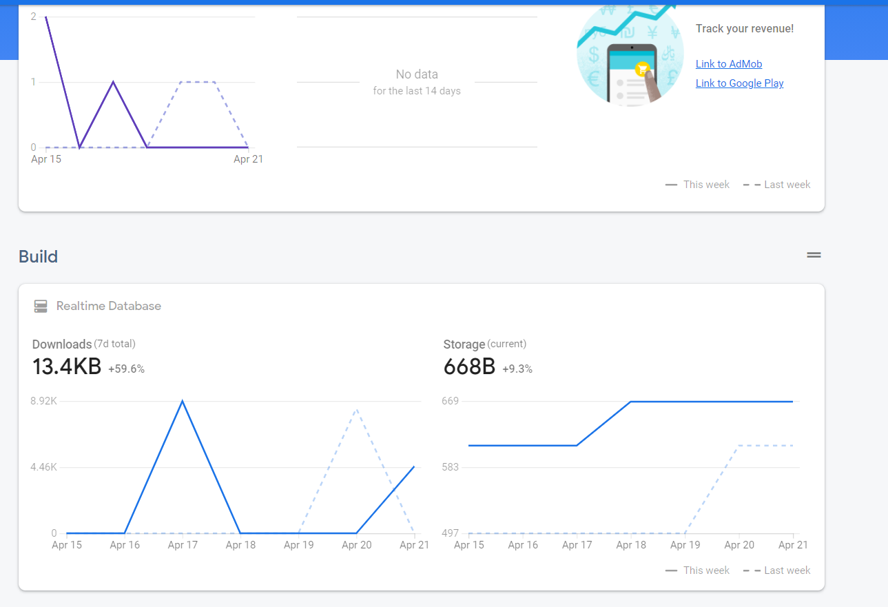

6. Bug list

In first version after answering some app automatically gets stopped

In second version there is empty bugs

7. Troubleshooting tips

Fixed code with few minor changes

8. Credits and acknowledgements

These are the sites used for calculating ideas

https://www.canada.ca/en/immigration-refugees-citizenship/services/immigrate-canada/express-entry/eligibility/criteria-comprehensive-ranking-system/grid.html

https://www.cic.gc.ca/english/immigrate/skilled/crs-tool.asp